Geographic Diversity in the United States
Identifying Major Geographic Features in the United States
Directions – On the accompanying map, label the following geographic features:
- 50 states
- 13 Original Colonies
- 5 Great Lakes
- 2 mountain ranges
- Atlantic Ocean
- Pacific Ocean
- Gulf of Mexico
- Mississippi River
- Great Plains
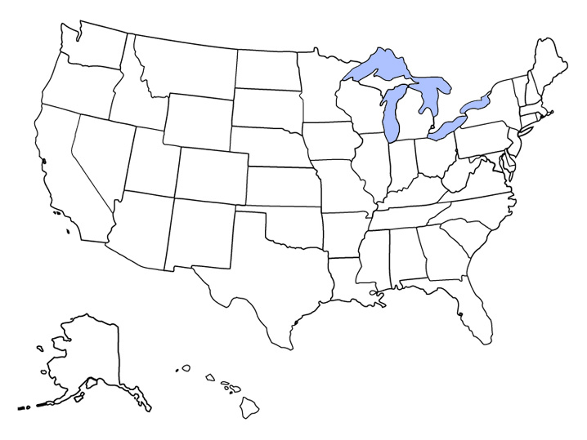

List 5 ways in which these geographic features have contributed to the development of the United States:
1.

2.

3.

4.

5.

Natural Resources in the United States
Directions – Analyze the maps below and record five natural resources in the United States and the states in which they are found.

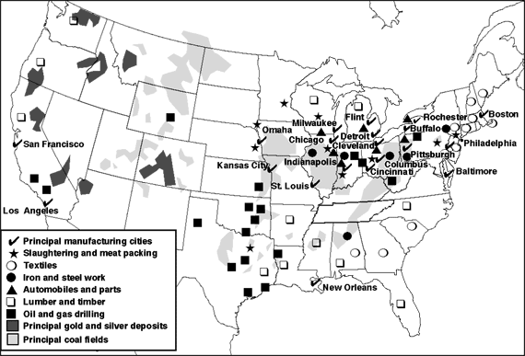

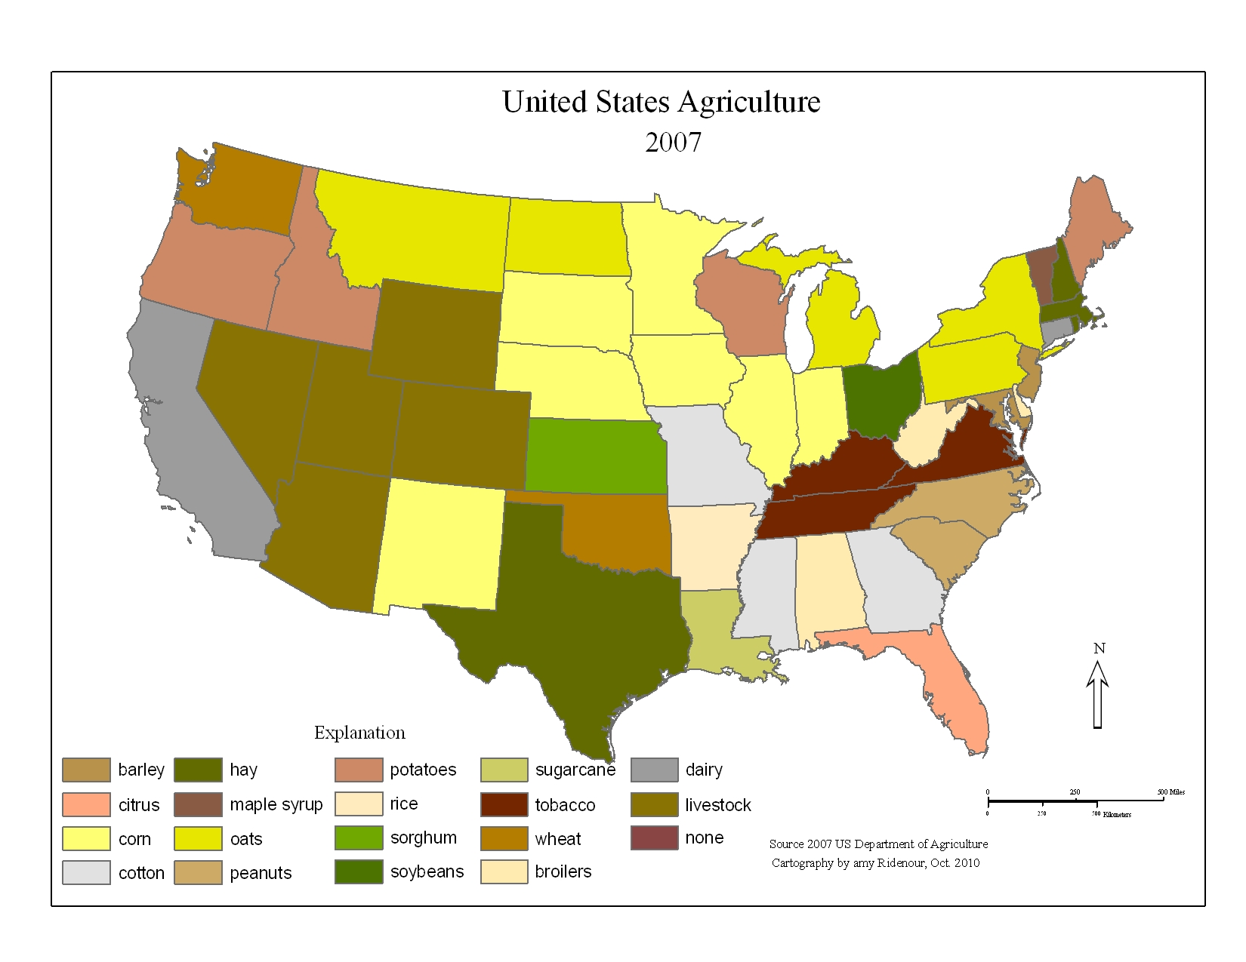
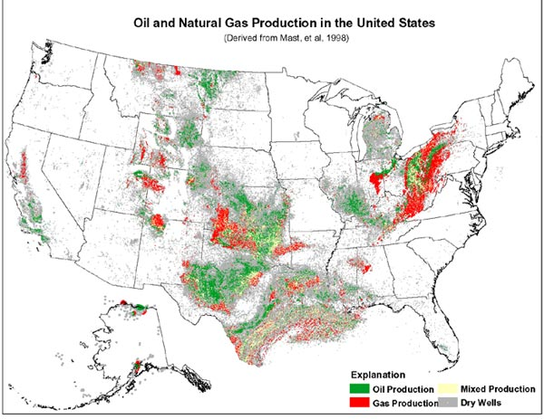

Natural Resources | States
- How has the presence of natural resources in the United States contributed to its economic success? Explain.

Climate in the United States
Directions – Analyze the climate maps below and record five climate types in the United States and some states found in each region. Then answer the questions that follow.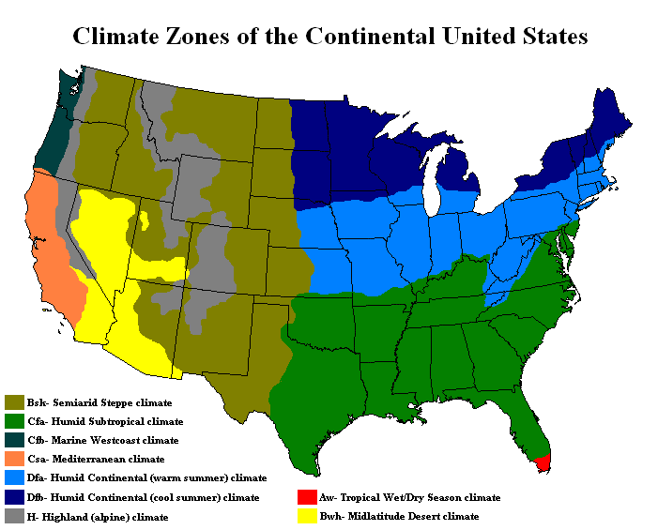
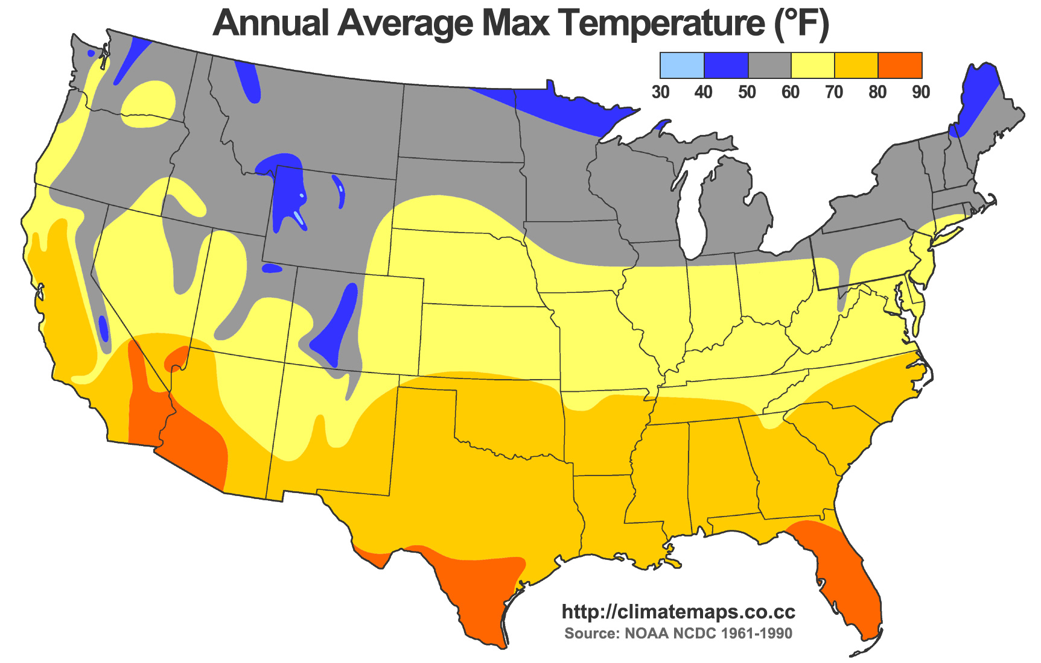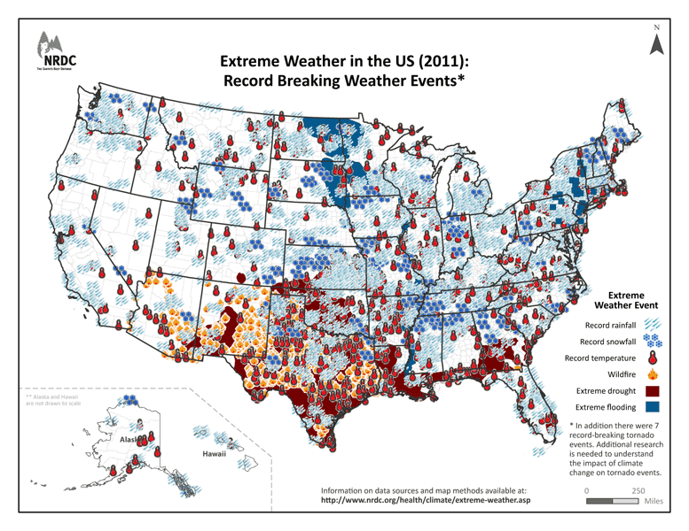

Climate Regions | States

- How have varying climates affected the development of the United States?

- What have been the causes and impact of recent extreme weather patterns in the United States?

Summary Questions

- In what ways is the United States a geographically diverse nation?

- What impact has geographic diversity had on the development of United States society, economy, and culture?

